**Ideation Phase**

**Brainstorm & Idea Prioritization**

|  |  |
| --- | --- |
| Date | 19 September 2022 |
| Team ID | PNT2022TMID07849 |
| Project Name | Inventory Management for Retailers |
| Maximum Marks | 4 Marks |

**Step-1: Team Gathering, Collaboration and Select the Problem Statement**

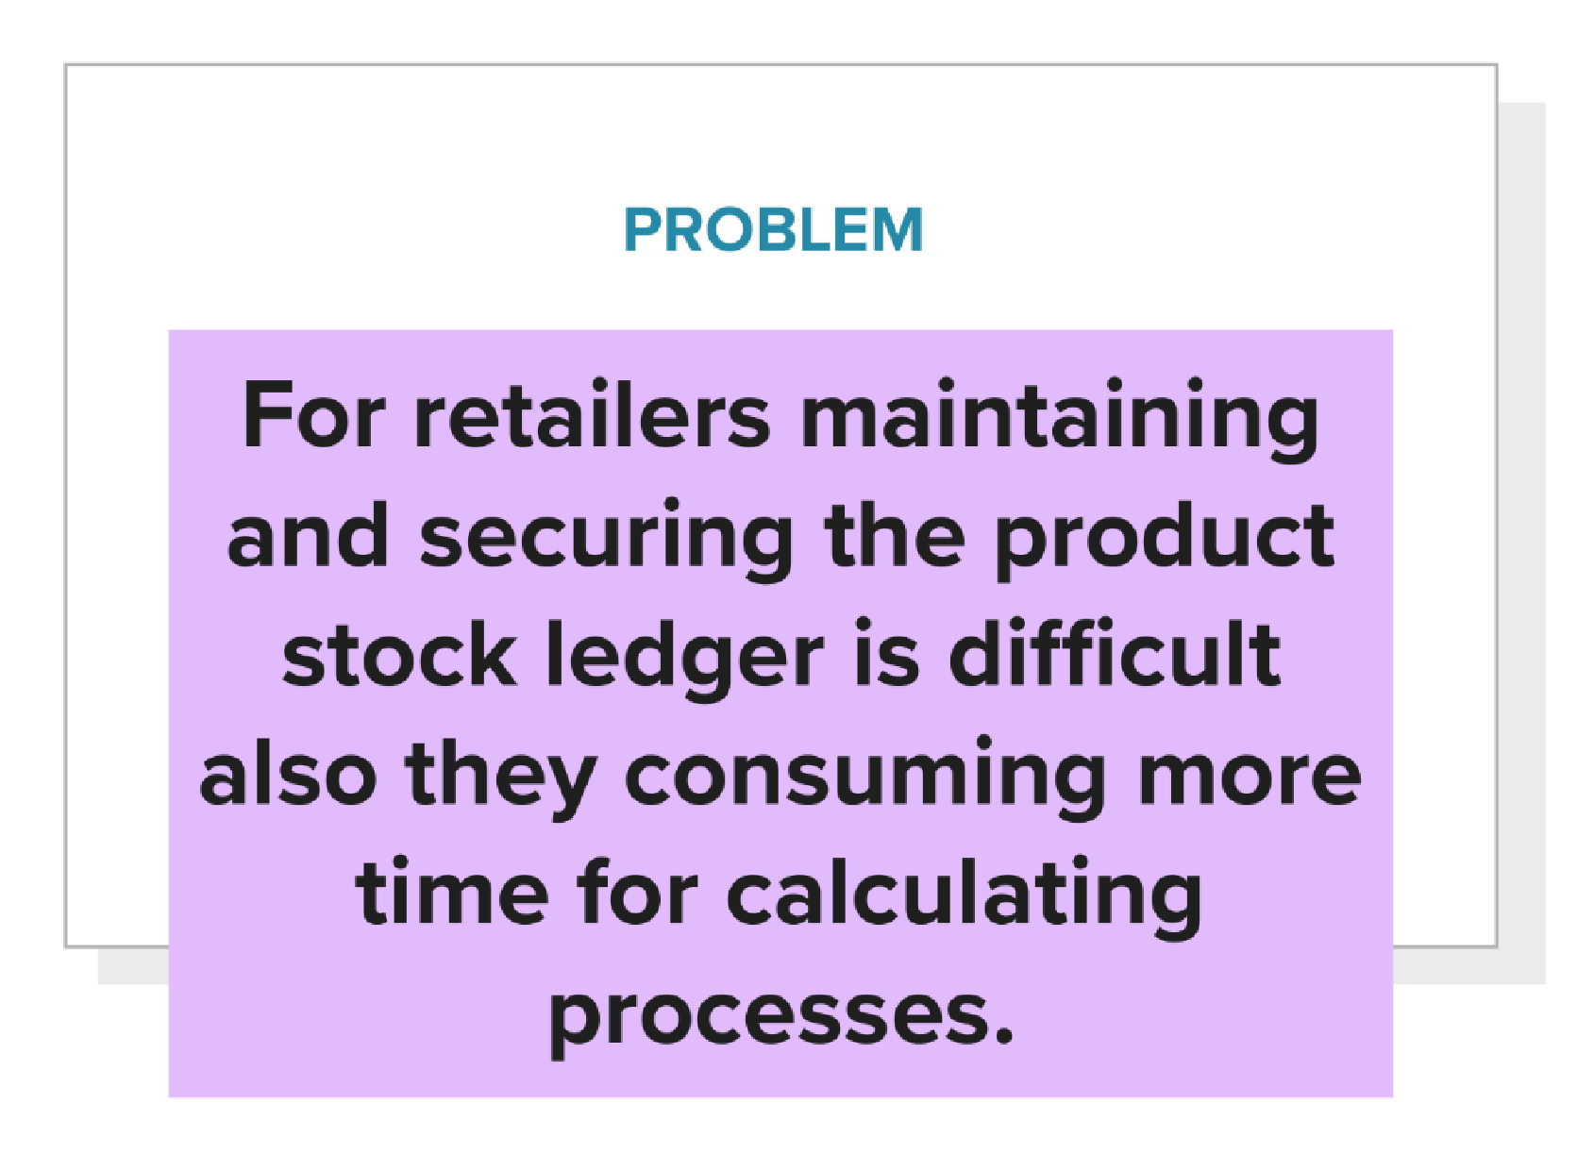

# Step-2: Brainstorm, Idea Listing and Grouping

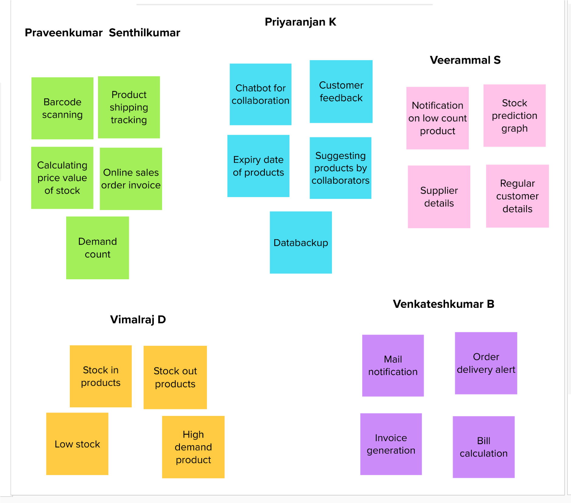

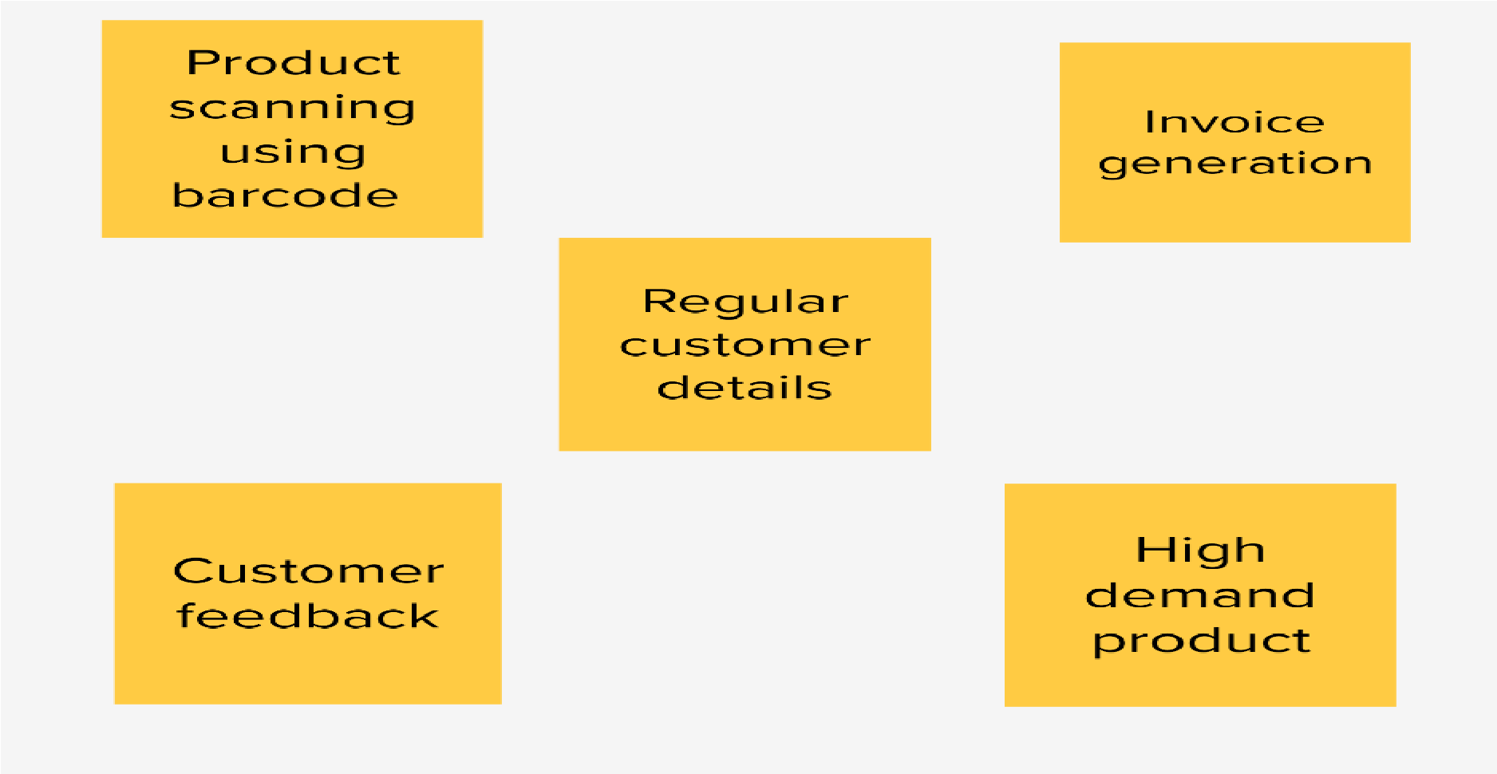

# Step-3: Idea Prioritization

